|  |  |
| --- | --- |
| **YEAR 8** | **Elastic Potential Energy** |

|  |  |
| --- | --- |
| **Learning Intentions** | **Success Criteria** |
| Understand elastic energy. | * Describe elastic energy. * Recognise and list examples of elastic potential energy. * Conduct experiments & investigations relating to elastic potential energy. |

**READ:** *Elastic Potential Energy*

**Elastic potential energy** is energy an object has when it is moved out of its ‘normal shape.’ This energy is transferred to kinetic and heat energy when the object springs back into shape. Things like springs and rubber bands are elastic. If you stretch or compress them then let go, they go back to their original shape.

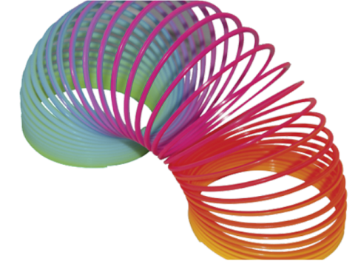

Image: <https://www.jing.fm/idown/oxJbTb_slinky-cliparts-transparent-slinky-png/>

**ACTIVITY 1:** *Slinky Drop Investigation*

**WATCH – VIDEO 1:** <https://www.youtube.com/watch?v=wGIZKETKKdw>

**YOUR TASK:** Predict what you would observe when a slinky is dropped.

1. Bottom end will fall first
2. Top end will fall first
3. Both ends fall together
4. Both ends snap towards centre

**WATCH – VIDEO 2:** <https://www.youtube.com/watch?v=eCMmmEEyOO0>

**ACTIVITY 2:** *Elastic Rockets*

**Purpose:** To investigate the effect of elastic band stretch on “rocket” launching distance.

**WATCH – VIDEO 3:** <https://www.jpl.nasa.gov/edu/learn/project/make-a-straw-rocket/>

**Directions:**

1. Draw a labelled diagram of the rocket launcher and the load in the space below.
2. Insert the straw rocket over the rubber band so the marked end is inside the launch tube.
3. Place the launch tube on the ground, along the start line.
4. Pull the bottom tip of the straw to the first mark (1 cm) and then let go.
5. Measure the distance the straw rocket travelled.
6. Repeat for each mark up to 10 cm.
7. Record your data in the table provided and then answer the discussion questions.

|  |
| --- |
|  |

**SAFETY!**

Always wear safety glasses.

Do not launch the elastic rocket above the ground or aim it at a person.

**Hypothesis:** Write a hypothesis for this investigation.

|  |
| --- |
|  |
|  |

**Variables:** Identify the following variables…

1. Independent variable (what is being changed): ________________________________
2. Dependent variable (what is being measured): ________________________________
3. Three controlled variables (what must stay the same - be specific):
4. _______________________________________________________________
5. _______________________________________________________________
6. _______________________________________________________________

**Results:**

|  |  |
| --- | --- |
| **No. of cm straw rocket is pulled back** | **Distance the straw rocket travelled (cm)** |
| **1** |  |
| **2** |  |
| **3** |  |
| **4** |  |
| **5** |  |
| **6** |  |
| **7** |  |
| **8** |  |
| **9** |  |
| **10** |  |

**Graphing:** Graph the results from this investigation on the grid below.



_____________________________________ ( _____ )

_____________________________________ ( _____ )

**Discussion:**

**Question 1 –** Describe the trend you observed in your experiment. Use data to support your answer.

|  |
| --- |
|  |
|  |
|  |
|  |

**Question 2 –** Describe the effect of stretching the rubber band on the amount of kinetic energy produced. Give examples from the graph to support your answer.

|  |
| --- |
|  |
|  |
|  |
|  |
|  |
|  |
|  |

**Evaluation:**

When you conduct experiments errors always occur. Outline one error that altered your results. Then explain what you could do to help reduce this error if you were to complete the experiment again.

|  |
| --- |
|  |
|  |
|  |
|  |
|  |
|  |
|  |
|  |

**Conclusion:** Write a conclusion for your experiment.

|  |
| --- |
|  |
|  |
|  |
|  |
|  |
|  |

REFERENCE: <https://www.youtube.com/watch?v=tR_jVfLNyQY>

**END OF WEEK TEST:** *Elastic Potential Energy*

**Question 1**

The image below shows how elastic potential energy can be transferred.

Annotate (add comments to) the diagram below to explain the transfer of energy that is occurring. I Image: <http://www.eschooltoday.com/energy/kinds-of-energy/what-is-elastic-energy.html>

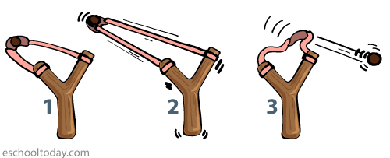

1. Explain which part of the sling shot will feel the warmest.

|  |
| --- |
|  |

**Question 2**

The image below states that a spring gains elastic potential energy when it is stretched and when it is compressed. Explain why the compressed spring and the stretched spring have elastic potential energy.

|  |  |
| --- | --- |
|  | spring-has-eleastic-potential-energy.png  Image: <https://www.eschooltoday.com/energy/kinds-of-energy/what-is-elastic-energy.html> |

**Question 3**

The image below shows a pole vaulter using energy to lift them over the bar. For each point along the pole vaulters journey explain the energy transfers that are occurring starting with the chemical potential energy in the athletes body.

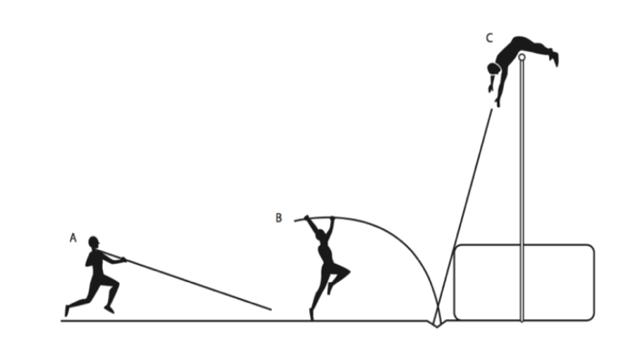

|  |  |
| --- | --- |
| **Point A** |  |
| **Point B** |  |
| **Point C** |  |

**Image:** https://spark.iop.org/sites/default/files/media/documents/Energy%20questions%20sheet%20-%20PDF.pdf

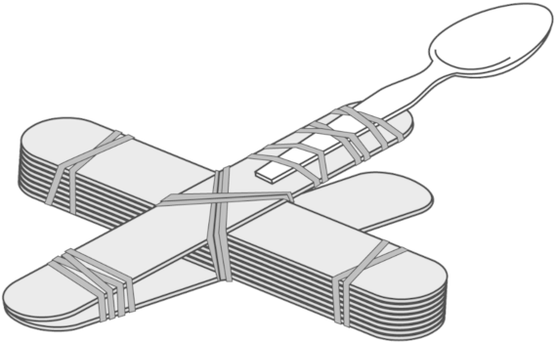

**Question 4**

A catapult demonstrates the use of elastic potential energy to fire objects.

Use an energy flow diagram to illustrate the transfer of energy from your hand that results in the object being fired. Image: <https://www.clipartmax.com/png/full/146-1465863_pogo-stick-clip-art.png>

|  |
| --- |
|  |

1. Describe some features that objects that have elastic potential energy have in common.

|  |
| --- |
|  |

Rate your understanding of elastic potential energy:  
 